

Tribhuvan University
Faculty of Humanities and Social Sciences
Kirtipur, Kathmandu

A Lab Report
On
Programming Logic & Techniques using Python (MCA504)

Submitted by
Name: Bishal Rijal
Roll No.: 6(Six)

Submitted to
Roshan Tandukar

Patan Multiple Campus
Patandhoka, Lalitpur

Department of MC
Affiliated to Tribhuvan University

Roshan Tandukar

………………...

Jun - 2026

Assignment 2
Write a function that computes factorial of a number if the input number is more than 5. 1
Write a function that takes a number as input and checks whether the input number is prime or not. 1
Write a function that take start and end number as inputs & display counting in your screen. (use time.sleep(sec) to take a pause while counting) 2
Write a function which accepts an argument and returns the data type of that argument. 2
Write a function that computes hypotenuse of a right-angled triangle by following the steps given below. 3
Write a recursive function to compute the sum of numbers up to the input number. 3
Write functions to add, subtract, multiply and divide two numbers. Use these functions to calculate the value of 4
Write a function to find the power of a number using lambda function. 4
Write a recursive function to implement Tower of Hanoi problem. 5
Perform slicing operations on a 2-dimensional list of size 3*3. 5
Create a list with the ordered pair {(2,3),(1,4),(4,2),(5,6),(6,2)} and a function that returns the sum of two numbers. Use list comprehension to get the sum of each ordered pairs. 6
Create a file with name Sample.txt and write some contents into it. Also read the contents of the file. Also copy the contents of the file to another file with name Copy.txt. 6

Write a function that computes factorial of a number if the input number is more than 5.

def factorial(n):
if n > 5:
result = 1
for i in range(1, n + 1):
result *= i
return result

print(factorial(6))
print(factorial(5))

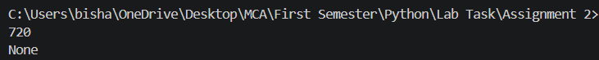

Write a function that takes a number as input and checks whether the input number is prime or not.

def is_prime(n):
if n <= 1:
return False
for i in range(2, n, 1):
if n % i == 0:
return False
return True

print(is_prime(7))
print(is_prime(10))

Write a function that take start and end number as inputs & display counting in your screen. (use time.sleep(sec) to take a pause while counting)
import time

def counting(start, end):
for i in range(start, end + 1):
print(i)
time.sleep(1)

counting(1, 10)

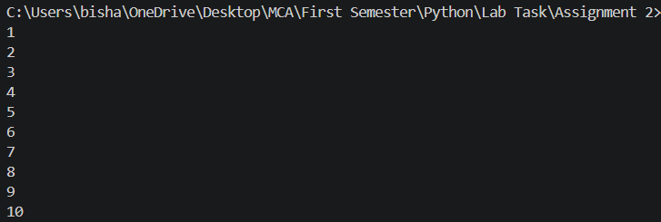

Write a function which accepts an argument and returns the data type of that argument.

def data_type(dt):
return type(dt)
print(data_type(5))
print(data_type(3.14))
print(data_type("Hello"))

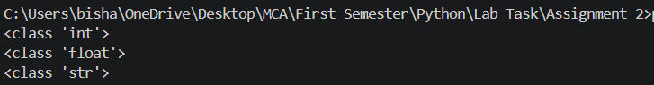

Write a function that computes hypotenuse of a right-angled triangle by following the steps given below.
Hypotenuse2 = Base2 + Perpendicular2
a) Take base and perpendicular as inputs.
b) Create a function calculateSquare() for calculating and returning square of a number.
c) Create a function calculateHypotenuse() for calculating hypotenuse of a right angle triangle. Make use of the calculateSquare() function.

import math
def calculateSquare(num):
return num ** 2

def calculateHypotenuse(base, perpendicular):
hypotenuse_squared = calculateSquare(base) + calculateSquare(perpendicular)
hypotenuse = math.sqrt(hypotenuse_squared)
return hypotenuse

base = float(input("Enter the base of the triangle: "))
perpendicular = float(input("Enter the perpendicular of the triangle: "))

hypotenuse = calculateHypotenuse(base, perpendicular)
print(f"The hypotenuse of the triangle is: {hypotenuse}")

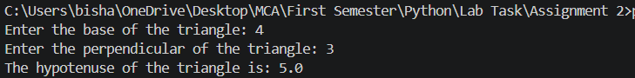

Write a recursive function to compute the sum of numbers up to the input number.
def sum_up_to(n):
if n <=0:
return 0
else:
return n + sum_up_to(n-1)

n = int(input("Enter a number: "))
print(sum_up_to(n))

Write functions to add, subtract, multiply and divide two numbers. Use these functions to calculate the value of
x = a(b+c)(c-a)/(a+b-c) where a=5, b=2 and c=4.
def add(x,y):
return x+y

def subtract(x,y):
return x-y

def multiply(x,y):
return x*y

def divide(x,y):
if y == 0:
return "Cannot divide by zero"
else:
return x/y

a = 5
b = 2
c = 4

calculation = divide(multiply(multiply(a, add(b,c)), subtract(c,a)), subtract(add(a,b), c))
print("The value of x is:", calculation)

Write a function to find the power of a number using lambda function.
power = lambda x, y: x ** y

number = int(input("Enter the base number: "))
exponent = int(input("Enter the exponent: "))

result = power(number, exponent)
print(f"{number} raised to the power of {exponent} is: {result}")

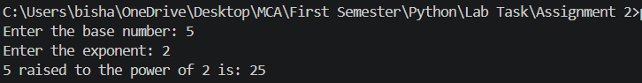

Write a recursive function to implement Tower of Hanoi problem.
def tower_hanoi(n, a,b,c):
if n == 1:
print("Move disk 1 from rod", a, "to rod", c)
return
tower_hanoi(n-1, a, c, b)
print("Move disk", n, "from rod", a, "to rod", c)
tower_hanoi(n-1, b, a, c)
print("Move disk", n, "from rod", a, "to rod", c)

n = 2
tower_hanoi(n, 'A', 'B', 'C')

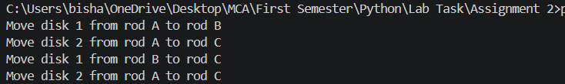

Perform slicing operations on a 2-dimensional list of size 3*3.

matrix = [
[1, 2, 3],
[4, 5, 6],
[7, 8, 9]
]

# Slicing the rows
print("First row:", matrix[0])
print("Second row:", matrix[1])
print("Third row:", matrix[2])

# Slicing the columns
print("First column:", [row[0] for row in matrix])
print("Second column:", [row[1] for row in matrix])
print("Third column:", [row[2] for row in matrix])

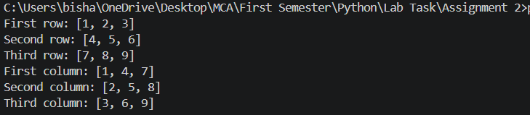

Create a list with the ordered pair {(2,3),(1,4),(4,2),(5,6),(6,2)} and a function that returns the sum of two numbers. Use list comprehension to get the sum of each ordered pairs.
ordered_pairs = [(2,3), (1,4), (4,2), (5,6), (6,2)]

def sum_of_numbers(x, y):
return x + y

sums = [sum_of_numbers(x, y) for x, y in ordered_pairs]
print("The sums of the ordered pairs are:", sums)

Create a file with name Sample.txt and write some contents into it. Also read the contents of the file. Also copy the contents of the file to another file with name Copy.txt.

with open("Sample.txt", "w") as file:
file.write("Hello Bishal!\nThis is a sample file.\nIt contains some text data.")

with open("Sample.txt", "r") as file:
contents = file.read()
print("Contents of Sample.txt:")
print(contents)

with open("Copy.txt", "w") as copy_file:
copy_file.write(contents)

print("Contents have been copied to Copy.txt"

